Description of actors and Stakeholders

There are three types of actors interacting with our system:

1. Low-Tech Operator
2. High-Tech Operator
3. Html writer

And one type of stakeholders:

1. Developer

*Low-Tech Operator:*

Low-Tech Operator is a farmer who uses the system to take information regarding his occupation. They are provided with a touch screen device which enables them to open an HTML page and navigate through it. For a farmer this can be really useful as they can view the manual for the machine they are operating. A farmer can zoom in or zoom out the page for better recognition of desired elements on page. This can be really helpful especially for people who have short-sightedness. Furthermore, farmers can follow links to find more specific information for what they are looking for.

*High-Tech Operator:*

High-Tech Operator is again a farmer who uses the system but he is provided with an extensive tool-a keyboard. This enables them except from the various things a typical farmer can do they can also use the keyboard for searching a particular text in the page. This is really useful for a farmer as he might not have the time to read the whole page for finding some information and he can just type text and the system will search to find it. It is also useful for farmers which are not enriched with a lot of knowledge and they do not care of reading anything irrelevant except finding out what they need to know.

*Html writer:*

Users of the system of this type are HTML writers who know the full syntax of HTML and can easily develop a web page using the tag notation of HTML. These are the people who create the pages according to the company’s requirements and of course the use of HTML. Their interaction with the system is mainly to write the HTML files and update them for the system.

*Developers:*

Developers are the people who have developed the system and can come at anytime in the future and change the program according to new requirements. They can update the system, modify it or add some more features in it. For example let’s say in the future the company decides to enable users to write their comments. This will definitely need developers’ involvement for modifying the system in a way to allow the rendering of more HTML tags for text input (example for rendering forms). Of course developers are needed for fixing a problem when there is something wrong with the system. Developers just like HTML writers do not interact directly with the system they are just stakeholders and they use another environment to modify the system.

**Basic and Alternatives course of events:**

1. *View manual*: Basic course of events:
   1. User clicks open to open a file
   2. System displays a browsing area for the user to choose among files.
   3. User browses the files directories to find the one he wants to open
   4. The system displays the HTML page successfully.
   5. The user views the manual
2. *View manual*: Alternative course of events:
   1. User clicks open to open a file
   2. System displays a browsing area for the user to choose among files.
   3. User browses the files directories to find the one he wants to open
   4. The system displays the HTML page with missing content because of wrong use of the tags or displays a pop up window because the directory does not exists.
3. *Zoom page*: Basic course of events:
   1. The user performs the “View manual” use case.
   2. The user choose zoom in or zoom out as many times as he needs.
   3. The system displays the zoomed in or out page.

2. *Zoom page*: Alternative course of events:

1. The user performs the “View manual” use case.

2. The user choose zoom in or zoom out as many times as he needs.

3. The system displays the same page because zoom in or out has exceeded its limits.

1. *Search page:* Basic course of events:
   1. The user performs the “View manual” use case.
   2. The user types a text to be searched in the page.
   3. The system displays the searched text in the page by highlighting all of the occurrences of the searched text.

*3. Search page:* Alternative course of events:

* 1. The user performs the “View manual” use case.

2. The user types a text to be searched in the page.

3. The system displays a pop up window telling the user that the text have not been found

1. *Follow link:* Basic course of events:
   1. The user performs the “View manual” use case.
   2. The user presses on a link.
   3. The system displays the linked page.

*4. Follow link:* Alternative course of events:

* 1. The user performs the “View manual” use case.
  2. The user presses on a link.
  3. The system is not able to find the page and displays an error informing the user.

**Use cases**

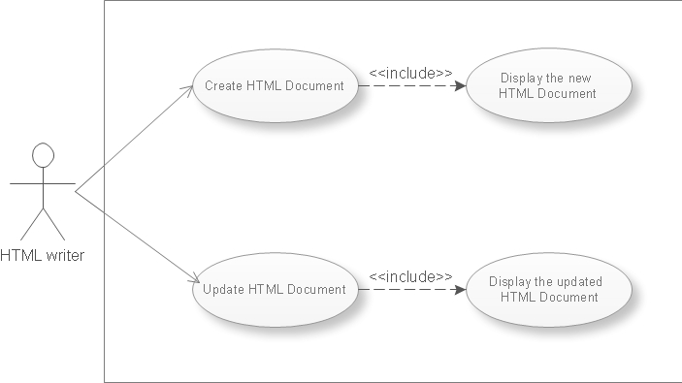

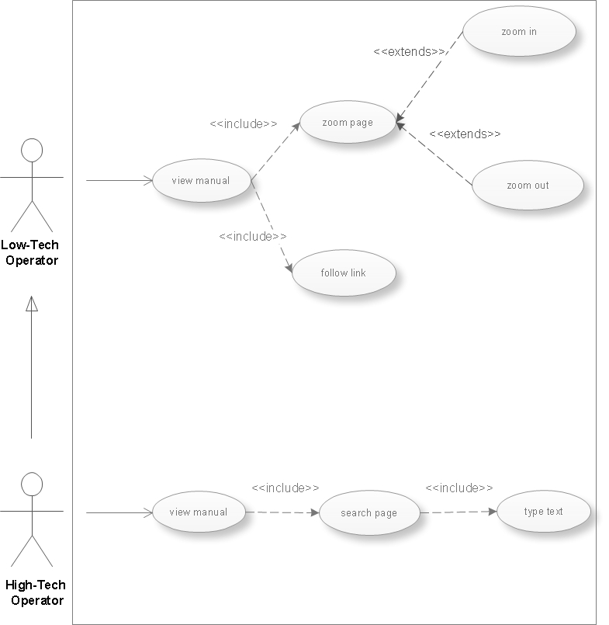

**CRC cards**

1. ***GUI***

|  |  |
| --- | --- |
| **Responsibilities** | **Collaborators** |
| open | Document |
| display | DocumentPanel |

1. ***Parser***

|  |  |
| --- | --- |
| **Responsibilities** | **Collaborators** |
| Send HTML tags | Document |
| Receive HTML tags | DocumentNode |

1. ***Document***

|  |  |
| --- | --- |
| **Responsibilities** | **Collaborators** |
| Send Document | GUI |
| Receive HTML tags | Parser |
|  | DocumentNode |
|  | DocumentPanel |
| Create HTML tags | Tokeniser |

1. ***DocumentPanel***

|  |  |
| --- | --- |
| **Responsibilities** | **Collaborators** |
| Receive Document | Searcher |
|  | GUI |
|  | HotLinker |
| Send Document | Document |

1. ***Tokeniser***

|  |  |
| --- | --- |
| **Responsibilities** | **Collaborators** |
| Send Document | Document |
|  |

1. ***HotLinker***

|  |  |
| --- | --- |
| **Responsibilities** | **Collaborators** |
| Send Document | DocumentPanel |

1. ***Searcher***

|  |  |
| --- | --- |
| **Responsibilities** | **Collaborators** |
| Read | DocumentPanel |
| Search | DocumentPresenter |
| Highlight text |  |

1. ***DocumentPresenter***

|  |  |
| --- | --- |
| **Responsibilities** | **Collaborators** |
| Manage the graphics | Searcher |
| Present Document | RenderNode |
| Highlight text | TextProvider |
|  | DocumentNode |

1. ***DocumentNode***

|  |  |
| --- | --- |
| **Responsibilities** | **Collaborators** |
| Manage HTML tags | Document |
|  | DocumentPresenter |

1. ***TextProvider***

|  |  |
| --- | --- |
| **Responsibilities** | **Collaborators** |
| Manage text | DocumentPresenter |

1. ***RenderNode***

|  |  |
| --- | --- |
| **Responsibilities** | **Collaborators** |
| Draw | DocumentPresenter |

### Identification of Collaborating Classes

**View manual**

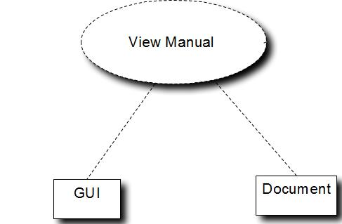

**Follow link**

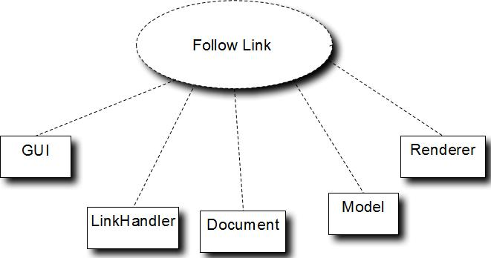

**Search page**

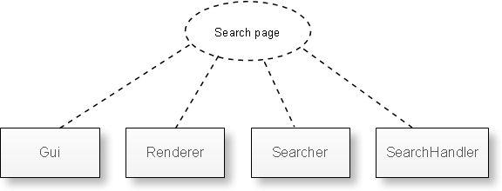

**Zoom page**

